Lab 2

Unfortunately the Lab this week for me is incomplete due to running out of time and not being able to come up with the solution. I did manage to complete Problems 1 – 4 though.

Output for the first 3 Problems:

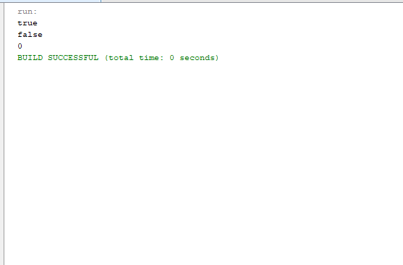
Problem 1: The complexity is O(n^2). I could change it to O(n log n) by sorting the array before checking if there is any duplicates in the array.

Problem 3: The complexity is O(n) as you only have to scan through the array and count the elements once.

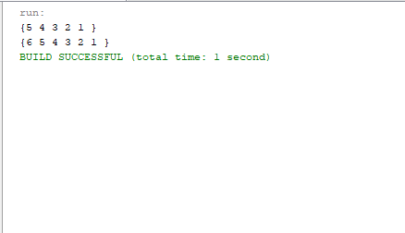
Output for Problem 4:

As I've said, I wasn't able to complete the last 2 due time restraints. That wont stop me from trying to solve the problems in my own time though despite taking a blow to my overall grade on the Lab.

